Confucianism (5 Key Relationships- Husband-Wife)
- "The woman follows the man. In her youth she follows her father and elder brother; when married, she follows her husband; when her husband is dead, she follows her son." (Bk. ix., 10.)
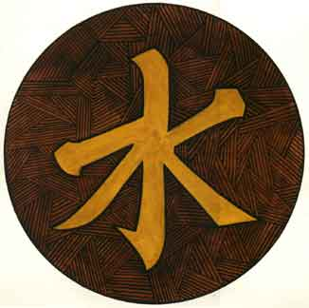
- "Here now is the affection of a father for his sons: He is proud of the meritorious among them and ranks those lower who are not so able. But that of a mother is such that, while she is proud of the meritorious, she cherishesthose who are not so able. The mother deals with them on grounds of affection rather than of pride; the father on grounds of pride rather than affection." (Li Ki, bk. xxix., 29.)
- "Faithfulness is requisite in all service of others and faithfulness is especially the virtue of a wife. Once mated with her husband, all her life she will not change her feeling of duty to him; hence, when the husband dies, she will not marry again." (Bk. ix., sect. iii., 7.)
- "At the marriage of a young woman, her mother admonishes her, accompanying her to the door on her leaving and cautioning her with these words, 'You are going to your home. You must be respectful. You must be careful. Do not disobey your husband!'" (Bk. iii., pt. ii., c. ii., v. 2.)
- "The bridegroom went in person to meet the bride, the man taking the initiative and not the woman—according to the idea that regulates the relation between the strong and the weak." (Bk. ix., sect. iii., 8.
Daoism on women
42:2 All things carry yin and embrace yang.
By blending these two breaths, they achieve balance.
43:1 The softest thing in the universe can overcome the hardest thing.
That which has no substance can penetrate where there is no space.
61:1 A large country is like the female of the world.
It is like the delta of a river.
61:2 The female overcomes the male by submission.
She places herself beneath him.
According to Taoist Cosmology, the first movement into manifestation happens via Yang Qi and Yin Qi – the primordial masculine and feminine energies. At this level, then, there is equality between the masculine and the feminine. They are understood to simply be two sides of the same coin: one could not exist without the other, and it is their “dance” which gives birth to the Five Elements (Earth, Fire, Water, Wood,and Metals), which in their various combinations produce the Ten Thousand Things, i.e. everything arising within the fields of our perception.
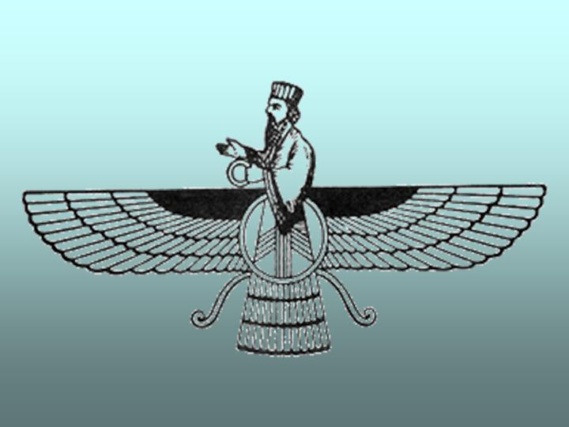
Zoroastrianism Gathas and Avesta on Women
- "May a good ruler, man or woman, rule over us in both the (mental and physical) existences." (H 7 - Y 41, st 2).
- "The Wise God knows better every man and woman among the living for his or her veneration done in accordance with righteousness. We, on our part, venerate such men and women."
- "We venerate the righteous woman who is good in thoughts, words, and deeds, who is well-educated, is an authority on religious affairs, is progressively serene, and is like the women who belong to the Wise God. "We venerate the righteous man who is good in thoughts, words, and deeds, who knows well the religion he has chosen, and who does not know blind following. It is these people who, with their actions, promote the world though righteousness." (Aiwisruthrem Gah 9 and Vispered 3.4)
- "The more a man or woman knows the truth, the better. He or she should zealously practice it and preach it to others so that they practice it accordingly." (H 1 = Y 35, st 6)
- "born in whatever land, both men and women, whose good consciences are growing, have grown, or shall grow ... good men and women (who are) incremental, eternal, ever-gaining, ever-growing, ... who live a life of good mind." (H 5 - Y 39, st 2-3).

Christianity and the Bible on Women
- 1 Timothy 2:12 I do not permit a woman to teach or to exercise authority over a man; rather, she is to remain quiet.
- Colossians 3:18 - Wives, submit to your husbands, as is fitting in the Lord.
- 1 Peter 3:1 - Likewise, wives, be subject to your own husbands, so that even if some do not obey the word, they may be won without a word by the conduct of their wives,
- 1 Corinthians 14:34-35 - The women should keep silent in the churches. For they are not permitted to speak, but should be in submission, as the Law also says. If there is anything they desire to learn, let them ask their husbands at home. For it is shameful for a woman to speak in church.
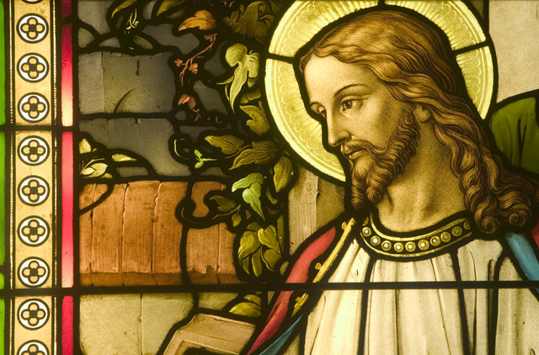
- Genesis 3:16 -To the woman he said, “I will surely multiply your pain in childbearing; in pain you shall bring forth children. Your desire shall be for your husband, and he shall rule over you.”
- 1 Peter 3:7 - Likewise, husbands, live with your wives in an understanding way, showing honor to the woman as the weaker vessel, since they are heirs with you of the grace of life, so that your prayers may not be hindered.
- 1 Timothy 2:13 - For Adam was formed first, then Eve;
- Colossians 3:19 - Husbands, love your wives, and do not be harsh with them.

Buddhist belief on Women becoming nuns
*Bhikkhuni = Female monk (nun) *Bhikkhu= Male Monk
According to Theravada tradition, the bhikkhuni order of nuns came to be five years after the bhikkhu order of monks.
Eight Rules for nuns in Buddhism is also known as the Eight Garudhammas:
1) A nun who has been ordained even for a hundred years must greet respectfully, rise up from her seat, salute with joined palms, do proper homage to a monk ordained but that day.
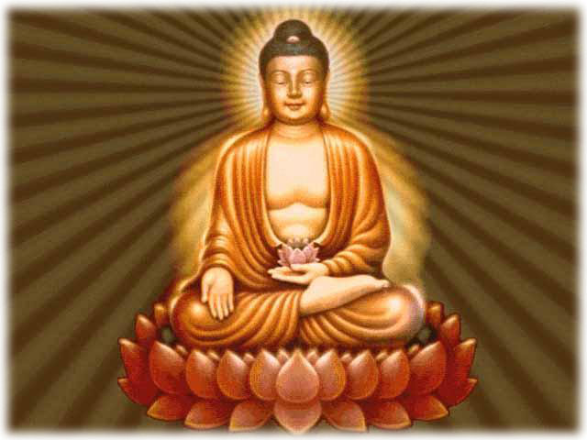
2) A nun must not spend the rains in a residence where there are no monks.^{[14]}
3) Every half month a nun should desire two things from the Order of Monks : the asking as to the date of the Observance [ uposatha ] day, and the coming for the exhortation [ bhikkhunovada ].^{[15]}
4) After the rains a nun must 'invite' [ pavarana ] before both orders in respect of three matters, namely what was seen, what was heard, what was suspected.^{[16]}
5) A nun, offending against an important rule, must undergo manatta discipline for half a month before both orders.
6) When, as a probationer, she has trained in the six rules [ cha dhamma ] for two years, she should seek higher ordination from both orders.
7) A monk must not be abused or reviled in any way by a nun.
8) From today, admonition of monks by nuns is forbidden.

*According to the vinaya, a bhikkhuni, unlike a bhikkhu, should not be accepted by the sangha to take these vows again in one life after "giving them back".^{[20][21]} So she cannot be a buddhist nun again.

 | Confucianism (E. Asia) | Buddhism (S.Asia) | Zoroastrianism (Mid East) | Christianity (Europe and Americas) | Taoism (E. Asia)
What is your impression of a woman’s place in society according to religion?
(Claim)
Provide Specific Evidence to support your impression
(Evidence)
Ranking: Give each religion a rating 1-10 of how restrictive it is on women with 1 being the least restrictive and 10 being the most restrictive. Then place them on the line.
10
1
5

Reflection: Look at the religions you ranked most and least restrictive? Do your rankings it surprise you? Explain
________________________________________________________________________________________________________________________________________________________________________________________________________________________________________________________________________________________________________________________________________________________________________________________________________________________________________________________________________________________________________________________________________________________________________________________________________________________

