Section 1 Page 302
Preview: Give three words that you think describe the Middle Ages?

- Kingdom of the Franks

List Characteristics of the New Germanic Kingdoms: 1 Per Bubble

2. How was the Church organized and who ran it? (Page 304 and 305)

3. Page 313
What were women’s roles? Who was Eleanor of Aquitaine?

4. Page 319 Growth of the European Kingdoms
Key Term | Main Ideas | Memory Clue
Holy Roman Empire
Mongol Rule

Byzantine Empire (322)

schism
Justinian Code

5. Chapter 10 Page 342 Medieval Christianity

Papal Monarchy

6. Inquisition Page 346
What was the purpose of the inquisition?

7. Page 355- What was the Great Schism?
8. Complete the Bubble Map
The Black Death

Ch 9 and 10: Middle Ages
400-1300

Target Goals Chapter 9 and 10:
1. What is the significance of Charlemagne?
2. What factors helped feudalism develop and what is it?
3. How did the Catholic Church change during the Middle Ages? Give 1 Example.
4. Describe the impact of the plague on society during the Middle Ages
The Goalie!
(Answer Target Goals and Discuss With Group, Group Leader)

1.

2.

3.

4.

The Questioner:
Come up with 2 Questions.
The “How” question must be framed in the way, “how did ____________________impact society today? Then ask one “Why” Question.
Question:

Answer:

Question:

Answer:

The Researcher:
Help answer the questions, complete timeline and discuss.
Timeline: Joan of Arc is Captured, Plague Spread to Italy and France, Christopher Columbus reaches Americas, Charlemagne crowned Roman emperor, Magna Carta signed, Crusades Begin

___________________________________________________________________________________

- On a scale of 1-10 rate how well you think you understand this section
1=No Clue
10-I am on fire!
Rating: __________
- On a scale of 1-10 rates how well your group discussed the ideas from this section, shared their thoughts and attempted to answer questions.
1= we didn’t even talk about it
10= we are on fire!
Rating: ____________

Chapter 12: Renaissance and Reformation 1350-1600
1. Page 398 (Write down at least 5 points from 398)

Italian Renaissance
2. What type of government did Italy develop?
City State | Description | Names and Dates
Milan
Venice
Florence

3. What are 3 main points from Machiavelli’s The Prince
1.
2.
3.

4. Complete the Chart
Piece of Literature | Divine Comedy | Canterbury Tales | The Book of the City of Ladies
Author

Main Ideas

5. Complete the Chart (Think Ninja Turtles!)

Artist | da Vinci | Michelangelo | Raphael
Famous Works

Styles, Description, Important Facts

6. The Protestant Reformation
Important People, Events | Description | Memory Clue
Martin Luther

95 Thesis

Erasmus

Lutheranism

Section 4: The Spread of Protestantism Page 418

7. Who was John Calvin and why was he important?

8. Who was Bloody Mary, and what was her father like?

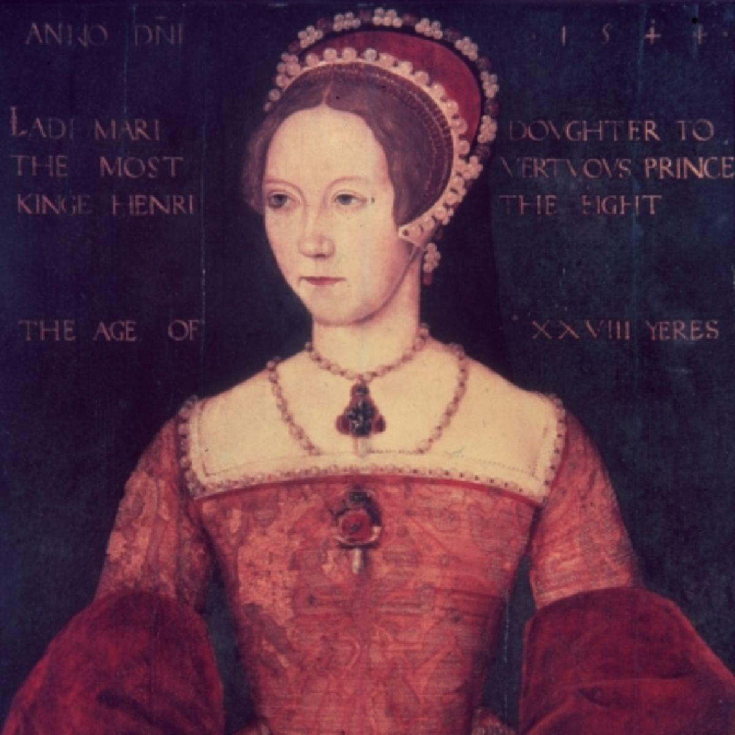

9. Using your Cell Phone or a computer research 3 interesting facts about Henry VIII, then listen to the song by Herman’s Hermit’s and draw a representation of the song.

Ch 12: Renaissance and Reformation

Target Goals Chapter 12:
1. What city states became centers of Renaissance learning and culture?
2. How did artists portray the world?
3. How were Martin Luther’s beliefs different from the Catholic Church?
4. Describe 2 new types of Christianity and how they were different.
5. Give one example in how the Catholic Church reacted to the new ideas around Christianity.
The Goalie!
(Answer Target Goals and Discuss With Group, Group Leader)

1.

2.

3.

4.

5.

The Questioner:
Come up with 2 Questions.
The “How” question must be framed in the way, “how did ____________________impact society today? Then ask one “Why” Question.
Question:

Answer:

Question:

Answer:

The Researcher:
Help answer the questions, complete timeline and discuss.
Timeline: Italian Renaissance begins, Peace of Augsburg, Martin Luther presents 95 thesis, Catherine of Aragon gains the throne, King Henry VIII creates Church of England.

___________________________________________________________________________________

- On a scale of 1-10 rate how well you think you understand this section
1=No Clue
10-I am on fire!
Rating: __________
- On a scale of 1-10 rates how well your group discussed the ideas from this section, shared their thoughts and attempted to answer questions.
1= we didn’t even talk about it
10= we are on fire!
Rating: ____________

