Name:_____________________

Expectation: Everything will be completed ON this handout and turned into substitute on Monday.

Day 1:
American I: Unit 1

Outcome:

- Analyze European Motives for Exploration
- Analyze the Impact of the Columbian Exchange on American Indians and Europeans

Warm Up: 9-8-2016

- Write down everything you think you know about Columbus. Minimum 3 sentences. What type of person, what did he do, etc.

After 2-3 minutes the sub will let you turn and talk about your response.

Assignment: Read the following excerpt about Columbus from Lies My Teacher Told Me, answer the close reading questions, then fill out the T Chart. After 7-8 minutes you may turn and talk quietly about your chart filling in more information from your partner and your conversation.

Excerpt From Lies My Teacher Told Me

Christopher Columbus introduced two phenomena that revolutionized race relations and transformed the modern world: the taking of land, wealth, and labor from indigenous peoples, leading to their near extermination, and the transatlantic slave trade, which created a racial underclass.

Columbus's initial impression of the Arawaks, who inhabited most of the islands in the Caribbean, was quite favorable. He wrote in his journal on October 13, 1492: "At daybreak great multitudes of men came to the shore, all young and of fine shapes, and very handsome. Their hair was not curly but loose and coarse like horse-hair. All have foreheads much broader than any people I had hitherto seen. Their eyes are large and very beautiful. They are not black, but the color of the inhabitants of the Canaries," Columbus went on to describe the Arawaks' canoes, "some large enough to contain 40 or 45 men." Finally, he got down to business: "I was very attentive to them, and strove to learn if they had any gold. Seeing some of them with little bits of metal hanging at their noses, I gathered from them by signs that by going southward or steering round the island in that direction, there would be found a king who possessed great cups full of gold." At dawn the next day, Columbus sailed to the other side of the island, probably one of the Bahamas, and saw two or three villages. He ended his description of them with these menacing words: "I could conquer the whole of them with fifty men and govern them as 1 pleased."^

On his first voyage, Columbus kidnapped some ten to twenty-five Indians and took them back with him to Spain." Only seven or eight of the Indians arrived alive, but along with the parrots, gold trinkets, and other exotica, they caused quite a stir in Seville. Ferdinand and Isabella provided Columbus with seventeen ships, 1,200 to 1,500 men, cannons, crossbows, guns, cavalry, and attack dogs for a second voyage.

Close Reading Questions:

- What is the author’s opinion of Columbus?

- What evidence does the author use to support his opinion?

- List 3 powerful words or phrases the author uses to describe his opinion.

- Why do you think the author has this opinion of Columbus?

Columbus
______________________________________________________________________________
Hero Villain

Written Response: In at least 5-7 sentences describe Christopher Columbus according to the excerpt Lies My Teacher Told Me. Then state your opinion on whether you think he was a Hero or a Villain in American history. Use at least 1 piece of evidence to back up your answer.

Write Here:

Day 2
American I Unit 1

Warm Up: Free Write about what you think the following map represents. 2-3 sentences minimum.

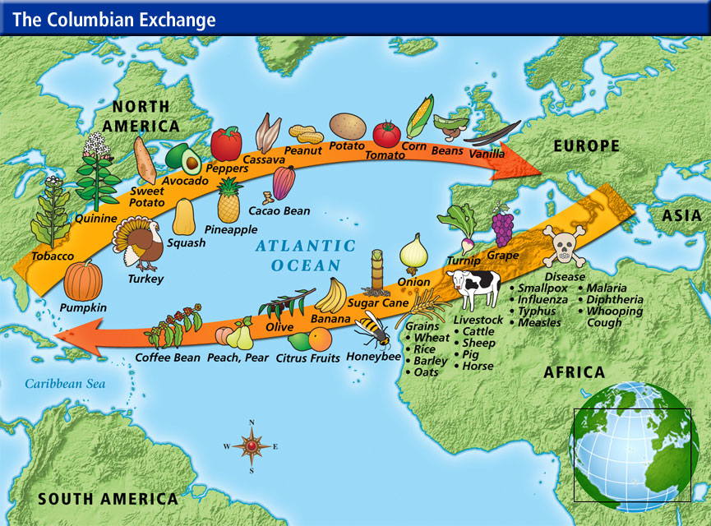

Write Here:

2. Slavery was a major part of the Columbian Exchange- Read the attached article and answer the questions at the end of the article

3. Read the Newsela Article and answer the following:

3 Things you thought were interesting:

2 Things you learned:

1 Question or something you wondered about the topic or article

(Share With a Partner Quietly)

See you Tuesday! Mrs. Dunbar

