Preview: Based on what our society leaves behind what do you think future people would think about American culture?

1. Write down key ideas for the following topics

Before History

Early Development

Paleolithic Age

2. Go back and define some of those key ideas.
Term | Define | How Long Ago Did They Live?  Where were the remains found?
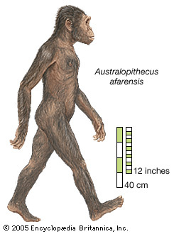Hominid
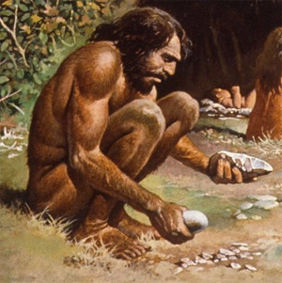
Homo Sapiens

3. Paleolithic Age 2,500,000 BC.-10,000 B.C.
Characteristic | Description | Provided For | How do we know? Evidence?
Hunting and Gathering
Stone Tools
Nomadic
Roles of Men and Women
Shelter
Use of Fire
Section 2: Neolithic Revolution 8000 B.C. -4000 B.C.  Change | Previous Method | Reason for Change | Benefits for Change
Systematic Agriculture
Domestication

4. Pick one of the following civilizations and describe their advancement during the Neolithic Revolution. Use specific examples.
Mesoamericans, Catalhuyuk

5. What happened between 4000 B.C. and 3000 B.C. that began to affect Neolithic towns? Explain 2 examples of how the Neolithic Age came to an end.

6. Describe each of the following characteristics of a civilization:
Cities
Government
Religion
Social Structure
Writing
Art

7. Do you agree with the book’s description of civilization? Do you think there could be groups of people are also civilized but don’t fit these categories? Explain

Ch 1: The First Humans

Target Goals Chapter 1:
1. Describe the development from hominids to homo sapiens.
2. Describe the characteristics of the Paleolithic Age. What were some of the major developments during this time period?
3. Describe the transition of humans from Nomadic hunters to farmers and herders as part of the Neolithic revolution.
The Goalie!
(Answer Target Goals and Discuss With Group, Group Leader)

1.

2.

3.

The Questioner:
Come up with 2 Questions.
The “How” question must be framed in the way, “how did ____________________impact society today? Then ask one “Why” Question.
Question:

Answer:

Question:

Answer:

The Researcher:
Help answer the questions, complete timeline and discuss.
Timeline: Paleolithic humans carve with stone tools, Home sapiens species develops, Neolithic Revolution, Mesoamericans domesticate dogs and fowl and grew beans, squash and, maize, Catalhuyuk, Copper used to make tools, Bronze Age, Iron Age

___________________________________________________________________________________

- On a scale of 1-10 rate how well you think you understand this section
1=No Clue
10-I am on fire!
Rating: __________
- On a scale of 1-10 rates how well your group discussed the ideas from this section, shared their thoughts and attempted to answer questions.
1= we didn’t even talk about it
10= we are on fire!
Rating: ____________

