Preview: Why do you think the first major civilizations were built near rivers? What can rivers provide to a growing population?

1. Sumerians contribution to civilization:

Political Life

Cultural Life

Inventions

2. Go back and define some of those key ideas.
Term | Define | How did it impact the progress of a civilization?
Fertile Crescent
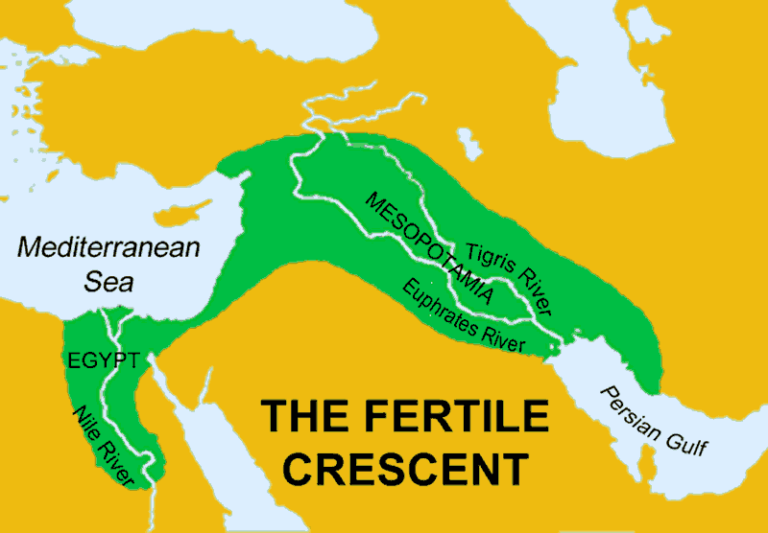
theocracy
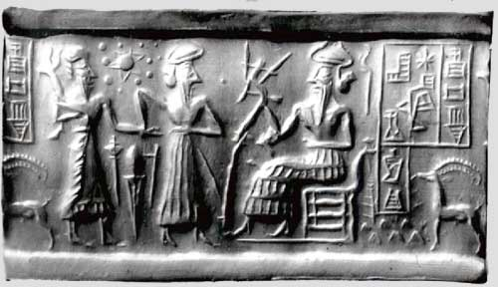

3. Empires in Ancient Mesopotamia (Be specific!)
Characteristic | Description | Effect on Society | Categorize: Political, Cultural, or Technological,
Polytheism
ziggurat

cuneiform
The Epic of Gilgamesh
Akkadians
Hammurabi’s Code
patriarchal

4. How did the Tigris and Euphrates Rivers support a strong economy in Mesopotamia?

5. Explain why Hammurabi’s code was a significant development and how it has impacted our lives today?

6. List characteristics of the three major periods of Egyptian History
The Old Kingdom | Middle Kingdom | The New Kingdom
Date, Major Rulers

Type of Government, Religion or religious practices

Inventions

7. Life in Ancient Egypt
Society
Daily Life: Gender Roles, Children, etc.
Writing and Education
Art and Science

7. How did the Hyksos both threaten and improve Egypt’s security?

8. Describe the importance of Nomadic peoples to improving civilizations around the world?

9.Describe how the Phoenicians impacted the development of Civilization in Southwest Asia

6. Describe how the Phoenicians impacted development in Southwest Asia.

Phoenicians

7. List the areas reached by Phoenician traders. Also list the areas that were colonized by the Phoenicians.

8.

Israelites

9. How did the Jews religious beliefs make them different from other peoples of their time and place?

11.

Assyrian Empire

Similarities

Persian Empire

11. Define the key ideas:

Term | Define | Impact on Society
Nebuchadnezzar

Cyrus

Darius

satrap

zoroaster

monotheism

polytheism

Ch 2: Western Asia and Egypt

Target Goals Chapter 2:
1. How did the physical environment affect the progress of the Fertile Crescent?
2. What were the major achievements of Egyptian Civilization and how did its geography affect its success?
3. What characteristics did the Assyrians and Persians have that contributed to their success and/or downfall.
The Goalie!
(Answer Target Goals and Discuss With Group, Group Leader)

1.

2.

3.

The Questioner:
Come up with 2 Questions.
The “How” question must be framed in the way, “how did ____________________impact society today? Then ask one “Why” Question.
Question:

Answer:

Question:

Answer:

The Researcher:
Help answer the questions, complete timeline and discuss.
Timeline: Sumerian Cities emerge, Great Pyramid of Khufu completed, Hammurabi’s code, Solomon becomes King of Israel, Darius I expands Persia’s empire.

___________________________________________________________________________________

- On a scale of 1-10 rate how well you think you understand this section
1=No Clue
10-I am on fire!
Rating: __________
- On a scale of 1-10 rates how well your group discussed the ideas from this section, shared their thoughts and attempted to answer questions.
1= we didn’t even talk about it
10= we are on fire!
Rating: ____________

