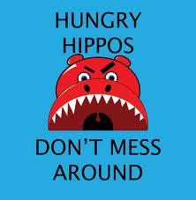 Feed Me Docs
Use your assigned documents to answer the following:
Name/Description of Document:
Historical Context
What is the context of the doc? What was occurring in time period & location?
Intended Audience
What audience did the author intend doc. for? How does it affect the subject matter?

Point of View
POV of Author? Background, position in society, beliefs

Purpose
Why was doc. created? What is author trying to convince reader?

Organization/Use in Argument
How will you use doc. in argument? How will it advance your argument?

