Date:___________________

Interactive Notes

Unit 1: Early Native American Society and Colonial History

Outcome 1: analyze the social & economic effects of exploration pre-1630 (P1 and P2)

North American Societies Around 1492
Southwest:

Pre- Columbus: 3,000 Years Ago- Anasazi

Pueblo

Eastern:

Pre-Columbus: Adena, Hopewell, and the Mississippian

Iroquois

Cultural Patterns:

Trading Networks: Trade was one of the biggest factors in bringing people together.

Social Organization: Kinship, division of labor
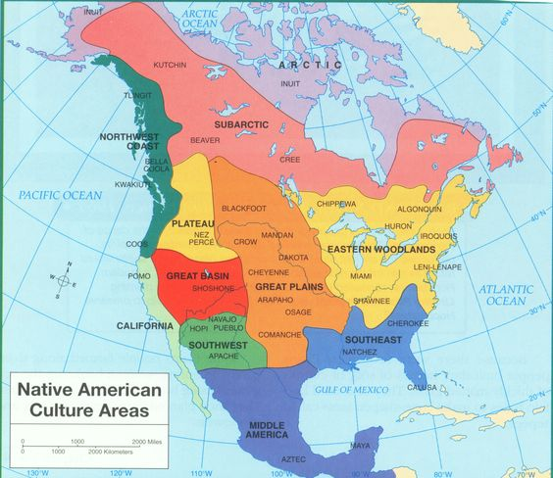

Highlight or circle the tribes that were talked about in the lecture.

American Colonies Emerge
Outcome 1: P3-P5

Reasons For Exploration
- Renaissance
- Crusades
- Reformation
- 3 G’s

Christopher Columbus

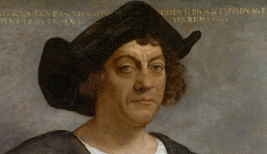
Hero or Villian?

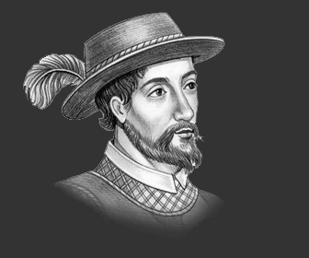
Juan Ponce de Leon
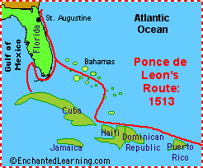

Treatment of Native Americans:

Pope’s Rebellion

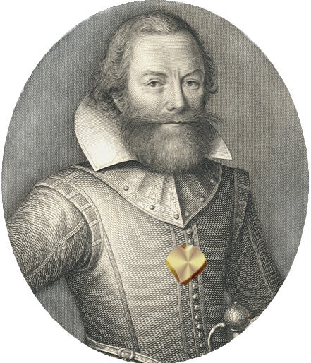

John Smith

The Business of Colonization: English colonies originally funded and maintained by joint-stock colonies.

In 1606 King James I of England granted a charter to the VA Company.

Settlement became known as Jamestown

Economic benefit of Tobacco- headright system and indentured servants

First African laborers- Dutch Merchant Ship in 1619. Indentured Servants

By 1622- English settlers began to battle Native Americans as a result of viewing Native Americans as uncivilized.

Impact of Colonization on Native Americans- Violence in Virginia angered James I and he revoked the colony’s charter and created a Royal Colony

