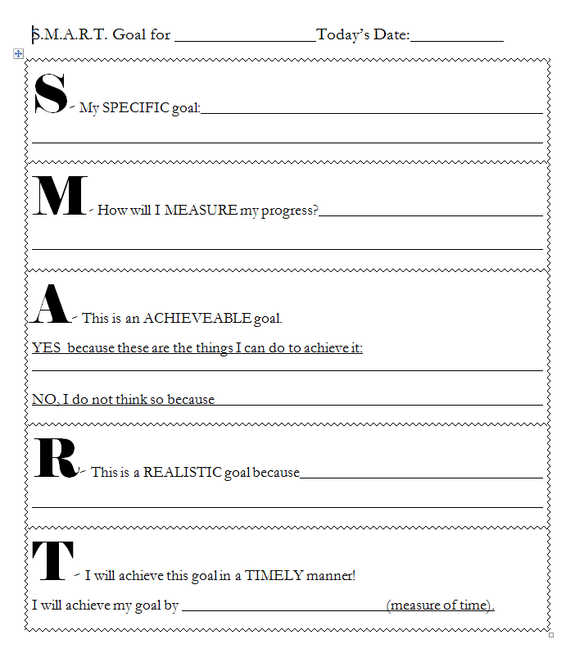

SMART Goal Check In
Date | On Way to Meeting Goal? Yes/No | If no, what needs actions do you need to take in order to still meet goal? | If yes, what do you need to continue to do to meet your goal?

